**SECUENCIA 7**

; PIC16F887 Configuration Bit Settings

; Assembly source line config statements

#include "p16f887.inc"

; CONFIG1

; __config 0x20D5

__CONFIG _CONFIG1, _FOSC_INTRC_CLKOUT & _WDTE_OFF & _PWRTE_OFF & _MCLRE_OFF & _CP_OFF & _CPD_OFF & _BOREN_OFF & _IESO_OFF & _FCMEN_OFF & _LVP_OFF

; CONFIG2

; __config 0x3FFF

__CONFIG _CONFIG2, _BOR4V_BOR40V & _WRT_OFF

LIST P=16F887

N EQU 0xD0 ; constante (EQU palabra reservada para guardar valores en espacios)

cont1 EQU 0x20 ;RETARDO

cont2 EQU 0x21 ;RETARDO

cont3 EQU 0x22 ;CONTADOR

V1 EQU 0x23

V2 EQU 0x24

ORG 0x00

GOTO INICIO ; GOTO comando para ir hacia

INICIO

BCF STATUS,RP1

BSF STATUS,RP0

MOVLW 0x71

MOVWF OSCCON ;RELOJ 8M

MOVLW 0x10

MOVWF TRISA

CLRF TRISD

BSF STATUS,RP1

CLRF ANSEL

BCF STATUS,RP0 ;BANCO 0

BCF STATUS,RP1

SECUENCIA7

MOVLW 0x01

MOVWF V1

MOVLW 0x80

MOVWF V2

MOVLW 0x05

MOVWF cont3

LOOP1

MOVF V1,0

IORWF V2,0

MOVWF PORTD

call DELAY

RRF V1 ;izquierda

RLF V2 ;derecha

BSF V1,7

BSF V2,0

DECFSZ cont3,1

GOTO LOOP1

;------------------------

MOVLW 0x10

MOVWF V1

MOVLW 0x08

MOVWF V2

MOVLW 0x05

MOVWF cont3

;--------------------------

LOOP2

MOVF V1,0

IORWF V2,0

MOVWF PORTD

call DELAY

RLF V1 ;izquierda

RRF V2 ;derecha

BSF V1,4

BSF V2,3

DECFSZ cont3,1

GOTO LOOP2

GOTO SECUENCIA7

DELAY

call RETARDO

call RETARDO

call RETARDO

call RETARDO

call RETARDO

call RETARDO

return

RETARDO

MOVLW N

MOVWF cont1

REP_1

MOVLW N

MOVWF cont2

REP_2

DECFSZ cont2,1

GOTO REP_2

DECFSZ cont1,1

GOTO REP_1

RETURN

End

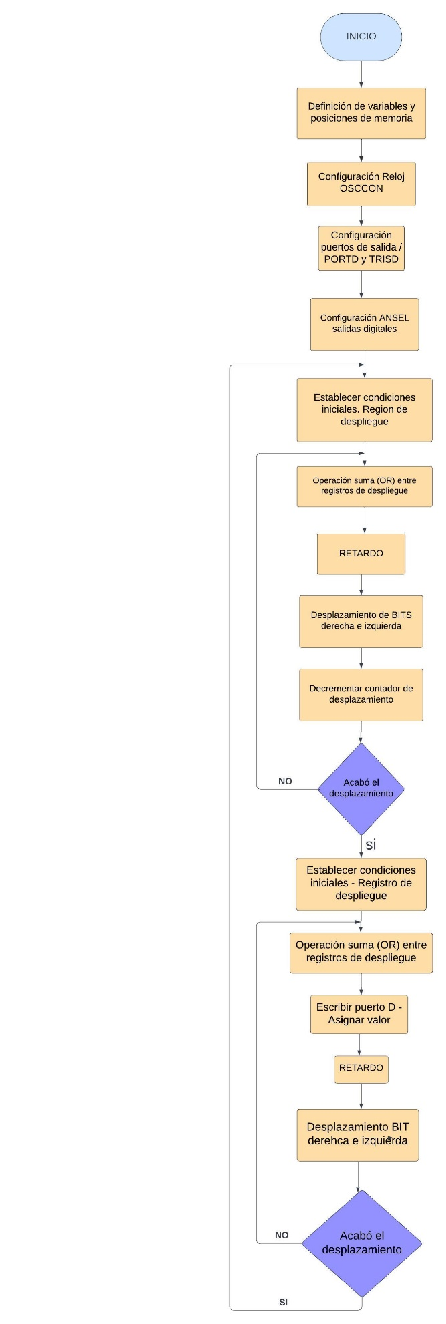

**SECUENCIA 5**

; PIC16F887 Configuration Bit Settings

; Assembly source line config statements

#include "p16f887.inc"

; CONFIG1

; __config 0x20D5

__CONFIG _CONFIG1, _FOSC_INTRC_CLKOUT & _WDTE_OFF & _PWRTE_OFF & _MCLRE_OFF & _CP_OFF & _CPD_OFF & _BOREN_OFF & _IESO_OFF & _FCMEN_OFF & _LVP_OFF

; CONFIG2

; __config 0x3FFF

__CONFIG _CONFIG2, _BOR4V_BOR40V & _WRT_OFF

LIST P=16F887

N EQU 0xD0 ; constante (EQU palabra reservada para guardar valores en espacios)

cont1 EQU 0x20 ;RETARDO

cont2 EQU 0x21 ;RETARDO

cont3 EQU 0x22 ;CONTADOR

V1 EQU 0x23

V2 Equ 0x24

ORG 0x00

GOTO INICIO ; GOTO comando para ir hacia

INICIO

BCF STATUS,RP1 ;RP1=0 bcf=0/bsf=1

BSF STATUS,RP0 ;BSF = fijar o poner en 1

MOVLW 0x71

MOVWF OSCCON ;RELOJ 8M

MOVLW 0x10

MOVWF TRISA

CLRF TRISD

BSF STATUS,RP1

CLRF ANSEL

BCF STATUS,RP0 ;BANCO 0

BCF STATUS,RP1

SECUENCIA5

MOVLW 0x01

MOVWF V1 ;derecha

MOVLW 0xA0

MOVWF V2 ;izquierda

MOVLW 0x02

MOVWF cont3

LOOP1

MOVF V1,0

IORWF V2,0

MOVWF PORTD

RLF V1

RRF V2

call DELAY

MOVF V1,0

IORWF V2,0

MOVWF PORTD

RLF V1

RlF V2

call DELAY

DECFSZ cont3,1

GOTO LOOP1

;------------------------

MOVLW 0x08

MOVWF V1

MOVLW 0xA0

MOVWF V2

MOVLW 0x02

MOVWF cont3

;--------------------------

LOOP2

MOVF V1,0

IORWF V2,0

MOVWF PORTD

RRF V1

RRF V2

call DELAY

MOVF V1,0

IORWF V2,0

MOVWF PORTD

RRF V1

RlF V2

call DELAY

DECFSZ cont3,1

GOTO LOOP2

GOTO SECUENCIA5

DELAY

call RETARDO

call RETARDO

call RETARDO

call RETARDO

call RETARDO

call RETARDO

return

RETARDO

MOVLW N

MOVWF cont1

REP_1

MOVLW N

MOVWF cont2

REP_2

DECFSZ cont2,1

GOTO REP_2

DECFSZ cont1,1

GOTO REP_1

RETURN

End

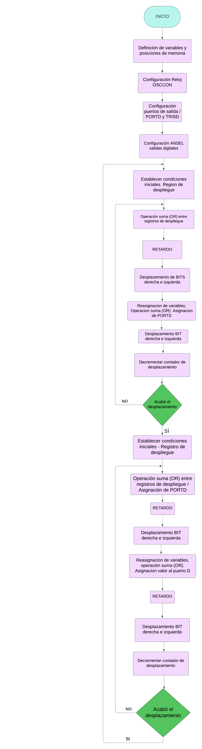

**SECUENCIA 10**

; PIC16F887 Configuration Bit Settings

; Assembly source line config statements

#include "p16f887.inc"

; CONFIG1

; __config 0x20D5

__CONFIG _CONFIG1, _FOSC_INTRC_CLKOUT & _WDTE_OFF & _PWRTE_OFF & _MCLRE_OFF & _CP_OFF & _CPD_OFF & _BOREN_OFF & _IESO_OFF & _FCMEN_OFF & _LVP_OFF

; CONFIG2

; __config 0x3FFF

__CONFIG _CONFIG2, _BOR4V_BOR40V & _WRT_OFF

LIST P=16F887

N EQU 0xD0 ; constante (EQU palabra reservada para guardar valores en espacios)

cont1 EQU 0x20 ;RETARDO

cont2 EQU 0x21 ;RETARDO

cont3 EQU 0x22 ;CONTADOR

V1 EQU 0x23

V2 Equ 0x24

ORG 0x00

GOTO INICIO ; GOTO comando para ir hacia

INICIO

BCF STATUS,RP1 ;RP1=0 bcf=0/bsf=1

BSF STATUS,RP0 ;BSF = fijar o poner en 1

MOVLW 0x71

MOVWF OSCCON ;RELOJ 8M

MOVLW 0x10

MOVWF TRISA

CLRF TRISD

BSF STATUS,RP1

CLRF ANSEL

BCF STATUS,RP0 ;BANCOS 0

BCF STATUS,RP1

SECUENCIA10

MOVLW 0x01

MOVWF V1

MOVLW 0x80

MOVWF V2

MOVLW 0x03

MOVWF cont3

IORWF V2,0

MOVWF PORTD

call DELAY

MOVLW 0x01

LOOP1

MOVF V1,0

ADDLW 0x02

MOVWF V1

RRF V2

MOVF V1,0

IORWF V2,0

MOVWF PORTD

call DELAY

DECFSZ cont3,1

GOTO LOOP1

;------------------------

MOVLW 0x03

MOVWF cont3

MOVF V1,0

ADDLW 0x02

MOVWF V1

IORWF V2,0

MOVWF PORTD

call DELAY

;-----------------------

LOOP2

MOVF V1,0

ADDLW 0x02

MOVWF V1

RlF V2

IORWF V2,0

MOVWF PORTD

call DELAY

DECFSZ cont3,1

GOTO LOOP2

GOTO SECUENCIA10

DELAY

call RETARDO

call RETARDO

call RETARDO

call RETARDO

call RETARDO

call RETARDO

return

RETARDO

MOVLW N

MOVWF cont1

REP_1

MOVLW N

MOVWF cont2

REP_2

DECFSZ cont2,1

GOTO REP_2

DECFSZ cont1,1

GOTO REP_1

RETURN

End

